1. 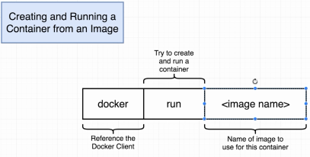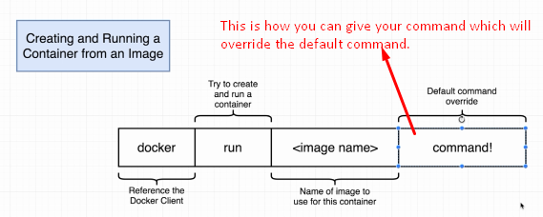
2. **docker ps**
   1. To list all the containers running now.
   2. **Docker ps --all** 🡸 To list all the running and have been created ever.